Lightning Component added to Lightning App Page.

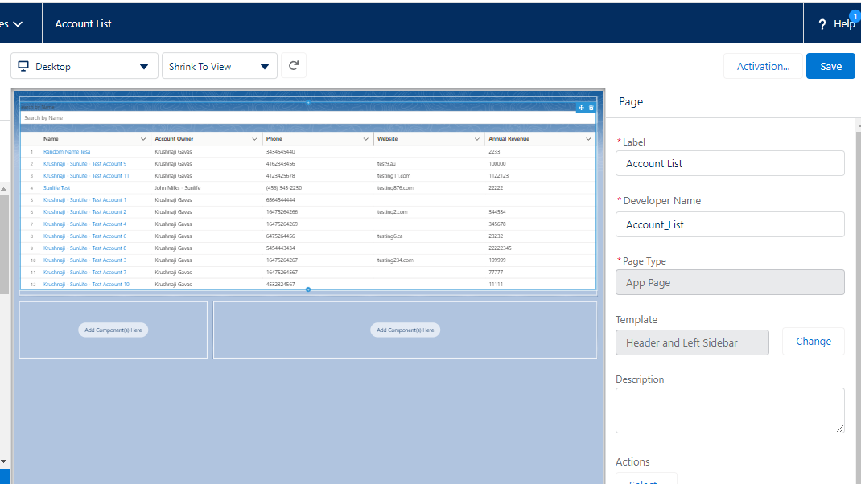

Added Lightning App Page as a button ‘ListAccounts’ on Account Page Layout.

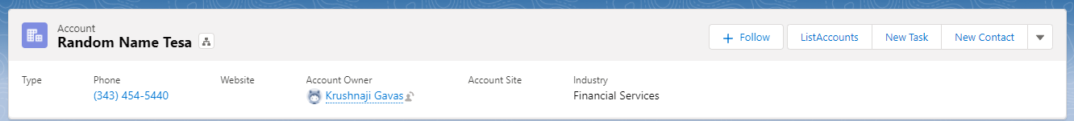

When User click on ListAccounts button, Account List open in a new Tab with ‘Financial Services’

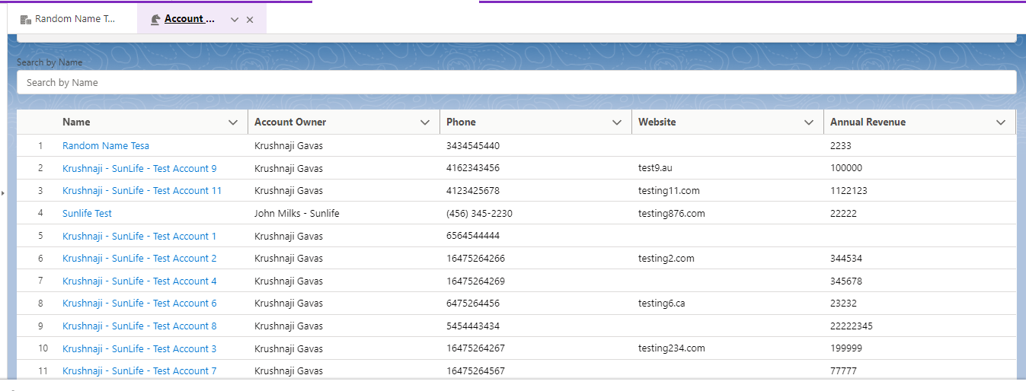

User can search list by Account Name

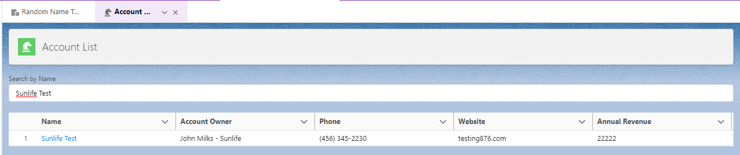

User can edit the record.

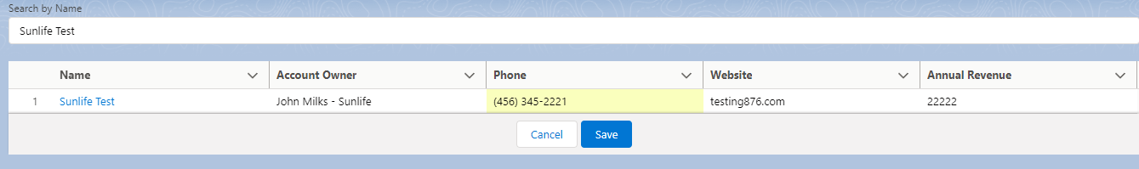

Refresh the Tab once you edit.

When User click on the account, it opens in the new tab.

